Exercise 7

Write a Java program that meets the following requirements.

1. Class name is Exercise7
2. File name is Exercise7.java
3. The program should declare a main method.
   1. In the main method the program should implement the logic in the diagram.

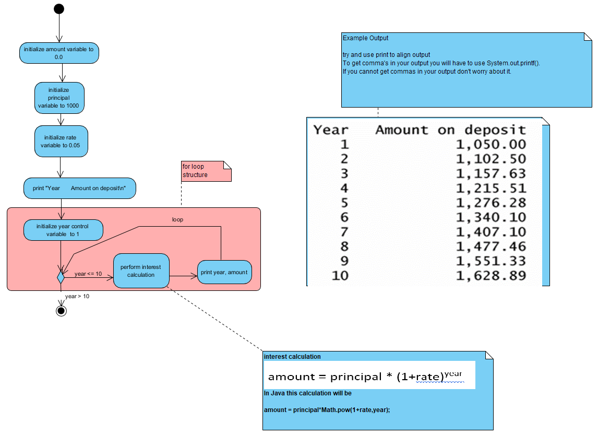

1. Your code must use a for loop.

NOTES:

* 1. Compile your code with the command: javac Exercise7.java
  2. Execute your code with the command: java Exercise7
  3. Your code output should match the output shown in the diagram. If you can’t get “commas” to show up in the output of the numbers that is ok.